*. Jira. Задача "Обновление движка Clamav" (https://jira.tcsbank.ru/browse/IN-1756)[Petrova Yulia].
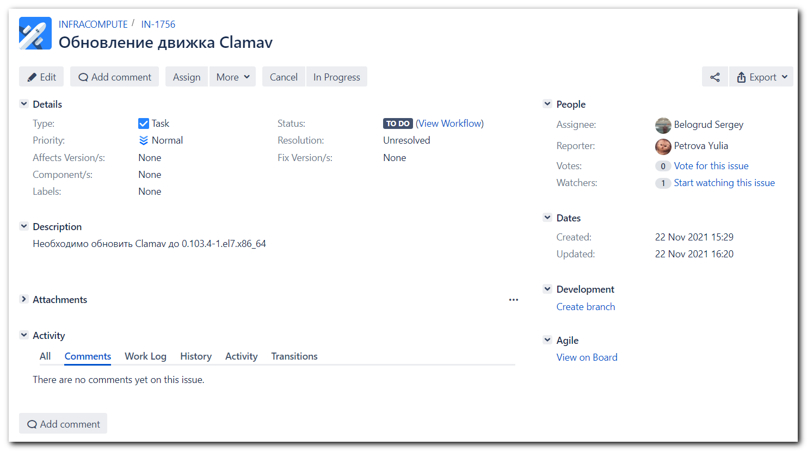

https://tinkoff.slack.com/archives/GHN18GB2M/p1637584238005100
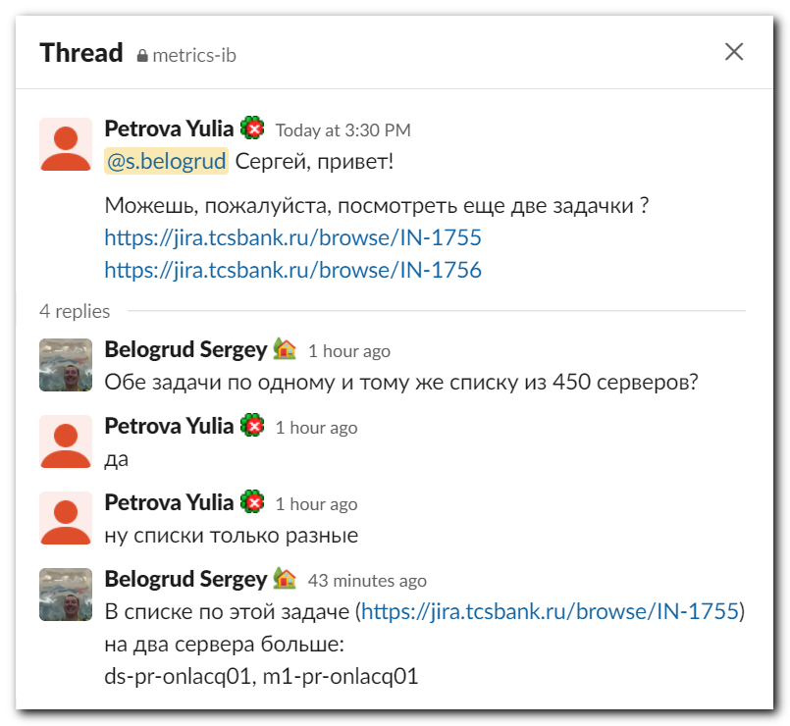

# Remember use "-f 10" option to run this command faster.
# And of course use "--tags packages" only to update the package. Again, it run this ansible task faster!
[support@nb2339]# export ANSIBLE_CONFIG=ansible.cfg ; logfile="$(date +%Y%m%d-%H%M).playbook.log.txt" ; ansible-playbook 20210816-1812.clamav.yml -i list_of_hosts --become --extra-vars "ansible_user=unix-ansible ansible_password=$(pass common/linux-unix-ansible) ansible_sudo_pass=$(pass common/linux-unix-ansible) ansible_ssh_common_args='-oStrictHostKeyChecking=no -oPubkeyAuthentication=no -oUserKnownHostsFile=/dev/null'" --tags package | tee -a ./output/${logfile}

# It were my changes to do this task. It was before Selin Pavel updated his ansible role.
[s.belogrud@nb2339]# git --no-pager diff vars/redhat.yml
diff --git a/vars/redhat.yml b/vars/redhat.yml
index 48c6d8a..9ccd46a 100644
--- a/vars/redhat.yml
+++ b/vars/redhat.yml
@@ -1,3 +1,8 @@
---
clamav_packages:
- - clamav-0.103.3*
+# - clamav-0.103.3*
+ - clamav-0.103.4*
+
+# - clamav-0.103.3-8*
+# - clamav-0.103.3*
+# - clamav-0.104.*
[s.belogrud@nb2339]# git --no-pager diff vars/redhat6.yml
diff --git a/vars/redhat6.yml b/vars/redhat6.yml
index fcb6f55..63f21a4 100644
--- a/vars/redhat6.yml
+++ b/vars/redhat6.yml
@@ -1,3 +1,4 @@
---
clamav_packages:
- - clamav-0.100.3*
+ # - clamav-0.100.3*
+ - clamav-0.103.4*
[s.belogrud@nb2339]# git --no-pager diff vars/redhat8.yml
diff --git a/vars/redhat8.yml b/vars/redhat8.yml
index cebb6e3..4f53944 100644
--- a/vars/redhat8.yml
+++ b/vars/redhat8.yml
@@ -1,4 +1,6 @@
---
clamav_packages:
- - clamav-0.103.3*
- - clamav-update-0.103.3*
+# - clamav-0.103.3*
+# - clamav-update-0.103.3*
+ - clamav-0.103.4*
+ - clamav-update-0.103.4*
[s.belogrud@nb2339]#

Nov 22, 2021 I asked Pavel update his ansible role. And he updated it.
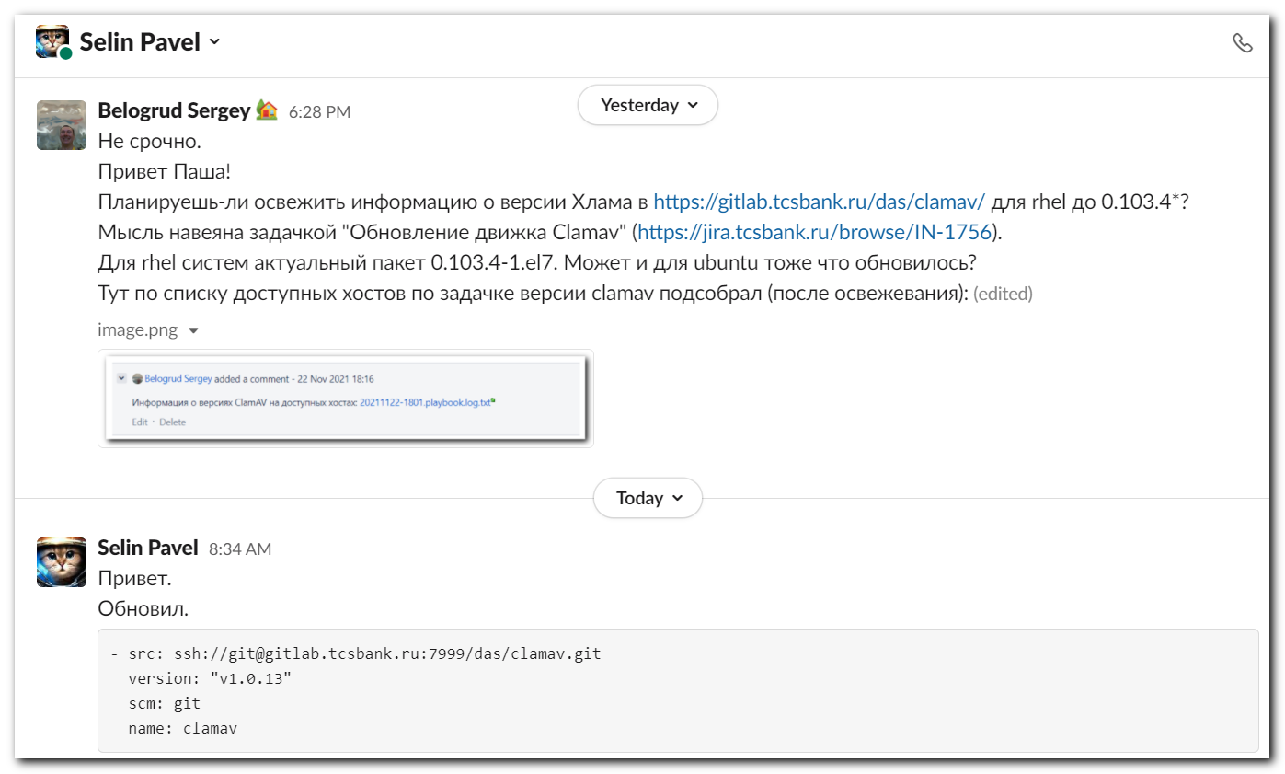

[s.belogrud@nb2339]# git pull
stty: standard input: Inappropriate ioctl for device
remote: Enumerating objects: 5, done.
remote: Counting objects: 100% (5/5), done.
remote: Compressing objects: 100% (4/4), done.
remote: Total 5 (delta 0), reused 5 (delta 0), pack-reused 0
Распаковка объектов: 100% (5/5), готово.
Из ssh://gitlab.tcsbank.ru:7999/das/clamav
aff6ab6..5df608b master -> origin/master
* [новая метка] v1.0.13 -> v1.0.13
Обновление aff6ab6..5df608b
error: Ваши локальные изменения в указанных файлах будут перезаписаны при слиянии:
vars/redhat.yml
vars/redhat8.yml
Сделайте коммит или спрячьте ваши изменения перед слиянием веток.
Прерываю
[s.belogrud@nb2339]# git checkout vars/redhat.yml
[s.belogrud@nb2339]# git checkout vars/redhat8.yml
[s.belogrud@nb2339]# git pull
stty: standard input: Inappropriate ioctl for device
Обновление aff6ab6..5df608b
Fast-forward
vars/redhat.yml | 2 +-
vars/redhat8.yml | 4 ++--
2 files changed, 3 insertions(+), 3 deletions(-)
[s.belogrud@nb2339]#

# Well, only couple changes were made.
https://gitlab.tcsbank.ru/das/clamav/-/commit/5df608b3f5774d8ba68ac0183ee0daea44f7417e
